1. **Introduction:**

1.1 The LOK SABHA is composed of representatives of people chosen by direct election on the basis of Universal Adult Suffrage. The constitution of India allows for a maximum of 550 members in the House, with 530 members representing the states and 20 representing the Union territories. The 17th Lok Sabha was formed by the members elected in the 2019 Indian election. Elections, all across India were conducted in seven phases from 11 April 2019 to 19 May 2019 by the election commission of India.

The Bharatiya Janatha Party received 37.36% of the vote, the highest vote share by a political party since the 1989 general election and won 303 seats, further increasing its substantial majority. In addition, the BJP-led National Democratic Akkiancr (NDA) won 353 seats.

* 1. The purpose of this project is to easily analyse the given data using tableau by creating colorful, understandable & attracting visualizations.

1. **Problem Definition & Design Thinking:**

**2.1 Brainstorming Map**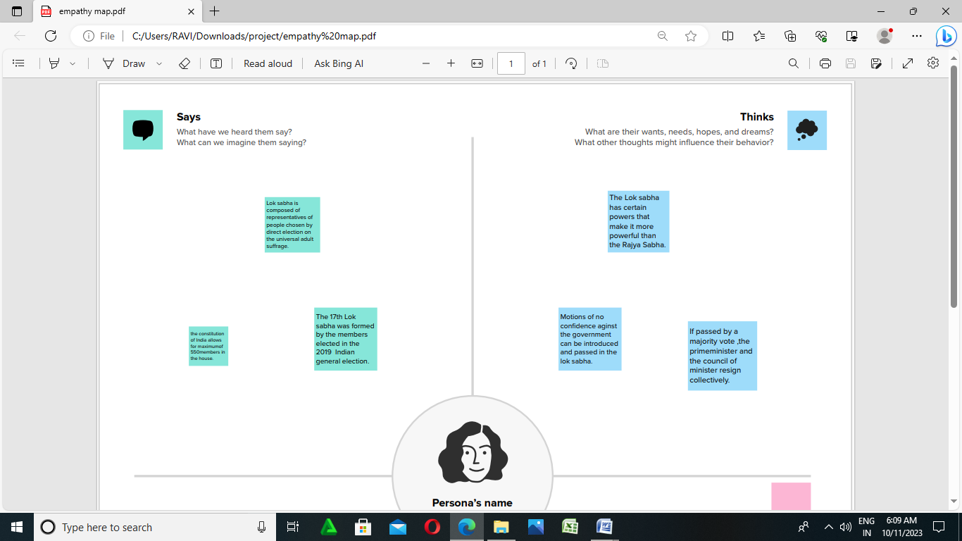

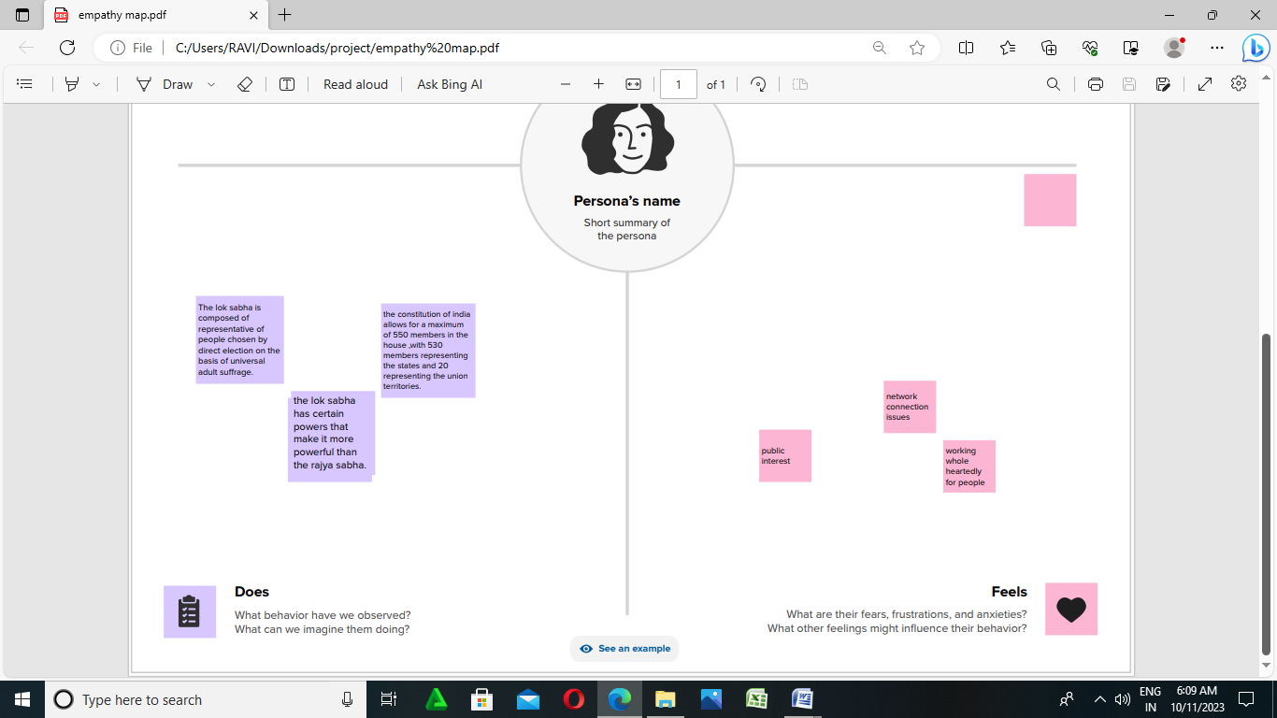

**2.2 Ideation & Brainstorming Map**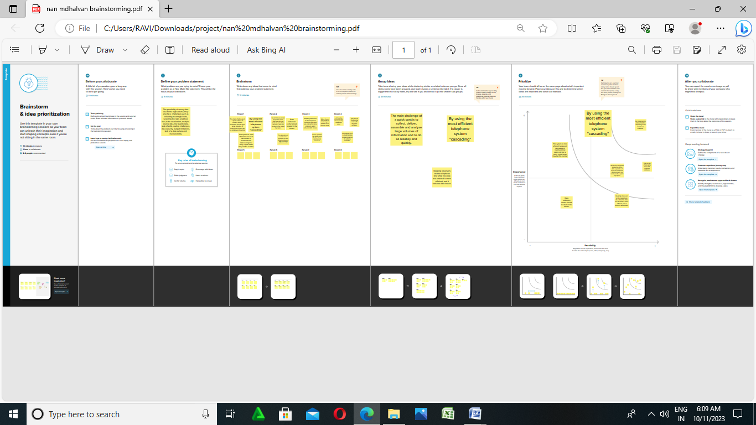

**3. Advantages:**

**Tableau dashboards are extremely useful because they may provide data in the form of stories, allow for the inclusion of various views and objects, offer range of layouts and styles, and allow users to apply appropriate filters. You may even effortlessly duplicate a dashboard or its individual features from one worksheet to another**

**5. Result:**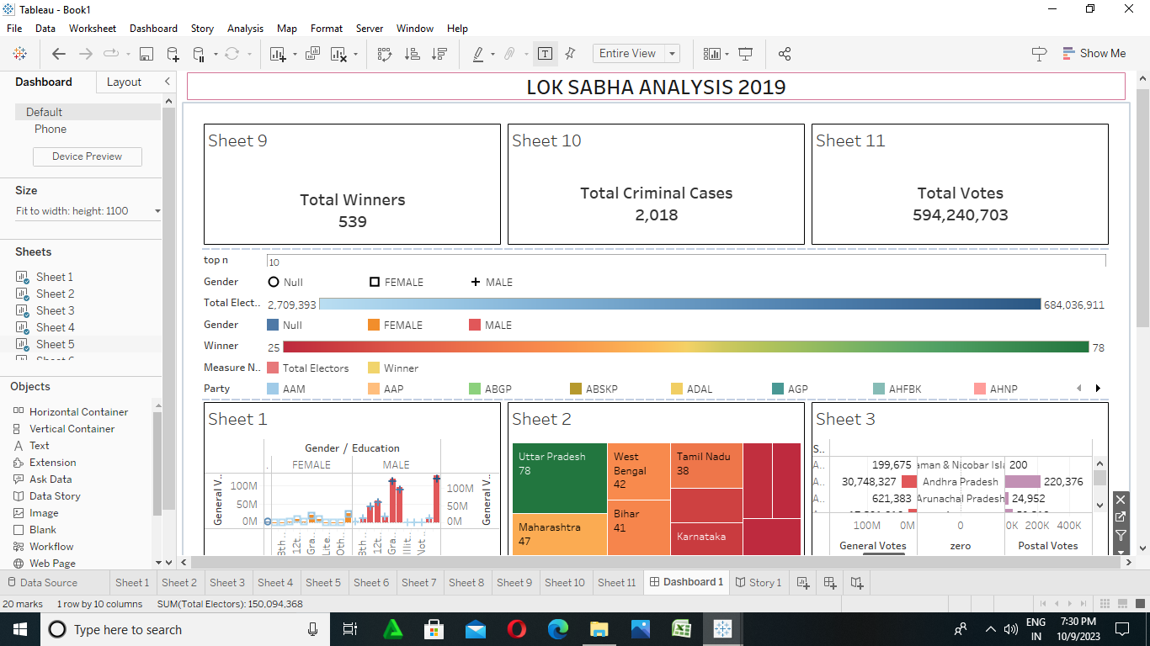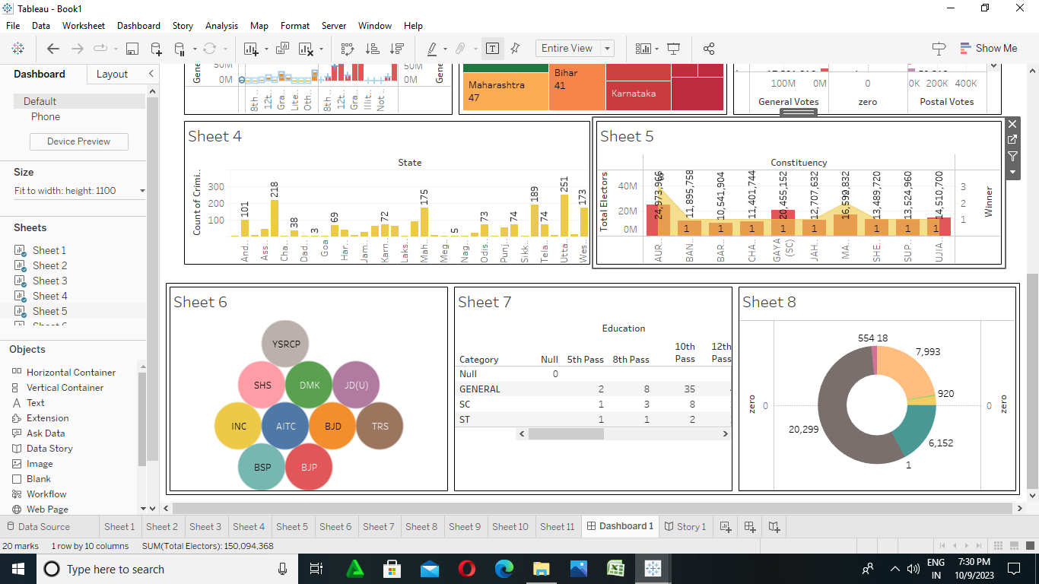

**6. Conclusion:**

**Using tableau we visualized the data of our project (political juggernauts : A quantitative analysis of Lok Sabha election 2019) in a easily understandable way.**